**Weather disaster and early warning Application**

***Undertaken By:***

**Faizan Sharif**

**CIIT/FA21-BSE-007/Vehari**

**Salman Sharif**

**CIIT/FA21-BSE-056/Vehari**

***Supervised By:***

**Kalim Sattar**



**A PROPOSAL SUBMITTED AS A NEW IDEA FULFILLMENT OF THE REQUIREMENTS FOR THE DEGREE OF BACHELORS IN SOFTWARE ENGINEERING**

**DEPARTMENT OF COMPUTER SCIENCES**

**COMSATS UNIVESITY ISLAMABAD, VEHARI CAMPUS**

**VEHARI – PAKISTAN**

**SESSION 2021-2025**

# Table of Contents

Table of Contents ii

1 Introduction 1

1.1 Project Overview 1

1.2 Background and Motivation 1

2 Aim and Objectives of the Project 1

2.1 Aim: 1

2.2 Objectives: 1

3 Proposed Solution 2

3.1 Functional Requirements 2

3.1.1 Cyclone Forecasting and Alerts 2

3.1.2 Rain and Heavy Rain Alerts 2

3.1.3 Notifications 2

3.2 Non-Functional Requirements 2

3.3 Technology Stack 3

4 Project Plan 3

4.1 Gantt Chart (Timeline) 3

5 Conclusion 3

6 References 3

# Introduction

## Project Overview

Weather disaster and early warning Application is a specialized software designed to provide real-time forecasts and alerts for severe weather conditions, focusing specifically on cyclones, tornadoes, heavy rain, and floods. It serves users in areas prone to these extreme weather events, offering timely and accurate information to enhance preparedness and reduce risk. By providing real-time data and early warnings, the system aims to help users make informed decisions and take necessary precautions to minimize the impact of natural disasters.

## Background and Motivation

Existing weather forecasting systems often provide general predictions, but few are dedicated to severe events like cyclones, tornadoes, heavy rain, and floods. Mainstream apps typically offer broad weather data but lack the real-time accuracy and focused alerts necessary for extreme weather conditions, leaving users vulnerable to delayed or insufficient warnings. The Weather disaster and early warning Application addresses this gap by focusing solely on these high-risk events, providing real-time, precise alerts that enable users to better prepare for and respond to life-threatening weather scenarios. This targeted approach ensures timely updates and improved safety measures compared to generic forecasting solutions.

# Aim and Objectives of the Project

## Aim:

To provide real-time, accurate alerts for cyclones, tornadoes, heavy rain, and floods to enhance preparedness and safety.

## Objectives:

* Deliver real-time alerts for severe weather events.
* Ensure accurate forecasts using reliable data.
* Provide early warnings to minimize disaster impacts.
* Create a user-friendly interface for easy access.
* Implement customizable alerts based on location.

# Proposed Solution

## Functional Requirements

### Cyclone Forecasting and Alerts

* Purpose: To provide real-time forecasts and alerts specifically for cyclones.
* Expected Behavior:
  + Tracking (Realtime tracking of the Cyclone and predictive track for next 24 hours)
  + Intensity alert (real time intensity and possible intensity for next 24h)
  + Strom surge forecasting and alert
  + Red zone alert
* Display cyclone tracking and intensity updates for user-specified locations.
* Send immediate alerts for impending cyclone threats.

### Rain and Heavy Rain Alerts

* Purpose: To provide forecasts and alerts for rain and heavy rain conditions.
* Expected Behavior:
* Display real-time rain forecasts and alerts for heavy rain events.
* Notify users about potential flooding due to heavy rainfall.
* Flood warning

### Notifications

* Purpose: To send real-time alerts to users for severe weather events.
* Expected Behavior:
* Provide immediate notifications via the app.

## Non-Functional Requirements

* **Performance:** The system should handle up to 1000 concurrent users with a maximum response time of 2 seconds for data retrieval and alerts.
* **Scalability:** The system should be able to scale horizontally to accommodate increased user load without performance degradation.
* **Security:** User data should be encrypted both in transit and at rest, and the system should comply with relevant data protection regulations.
* **Maintainability:** The codebase should be well-documented, allowing for efficient updates and maintenance. The system should support easy integration of new weather data sources.
* **Compatibility:** The application should be compatible with major web browsers (Chrome, Firefox, Safari, Edge) and mobile devices (iOS and Android).
* **Alert Timeliness:** Alerts should be generated and sent to users within 5 minutes of detecting a severe weather event.

## Technology Stack

* Flutter (Dart)
* Python (TensorFlow & request etc.)
* APIs

# Project Plan

## Gantt Chart (Timeline)

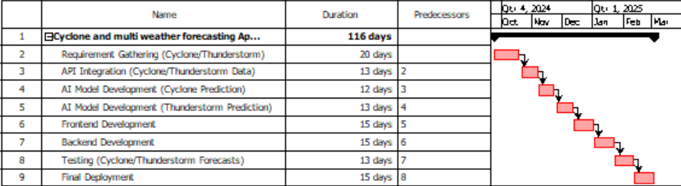

Figure 1.Gant Chart

# Conclusion

The Cyclone and Multi Weather Forecasting System is designed to enhance disaster preparedness by providing real-time, AI-driven predictions for cyclones, thunderstorms, rain, and flooding. Built using Flutter and integrated with advanced APIs, it delivers accurate weather forecasts and timely alerts, helping users take preventive measures during critical weather events. This project fills a vital gap in existing weather applications by focusing on severe weather phenomena, ensuring both accuracy and usability.

# References

1. National Oceanic and Atmospheric Administration (NOAA), "Cyclone Forecasting and Early Warnings," 2023. [Online]. Available: https://www.noaa.gov/weather-cyclones.

2. OpenWeatherMap, "Weather Data API Documentation," 2023. [Online]. Available: https://openweathermap.org/api.

3. Python Software Foundation, "Python for Data Science and Machine Learning Documentation," 2023. [Online]. Available: https://docs.python.org/3/.

4. Google Developers, "Flutter for Cross-Platform Mobile App Development," 2023. [Online].

Available: https://flutter.dev/docs.

5. World Meteorological Organization (WMO), "Global Weather and Climate Early Warning Systems," 2018. [Online]. Available: https://public.wmo.int/en/programmes/global-framework-climate-services.